This capture shows the system performing HTTP and OCSP requests over IPv6, which are part of normal HTTPS certificate validation. OCSP traffic is how the browser checks whether a website’s TLS certificate is still valid. This is a perfect example of “background security traffic” that SOC analysts need to recognize.
This capture shows HTTP and OCSP traffic over IPv6. OCSP (Online Certificate Status Protocol) is used by browsers and applications to verify the validity of TLS certificates. When a device connects to a secure HTTPS site, it may perform an OCSP check to ensure the certificate has not been revoked. The packets in this capture include HTTP GET requests to OCSP responder servers and corresponding responses containing certificate status information. This traffic is normal and part of the HTTPS security process.
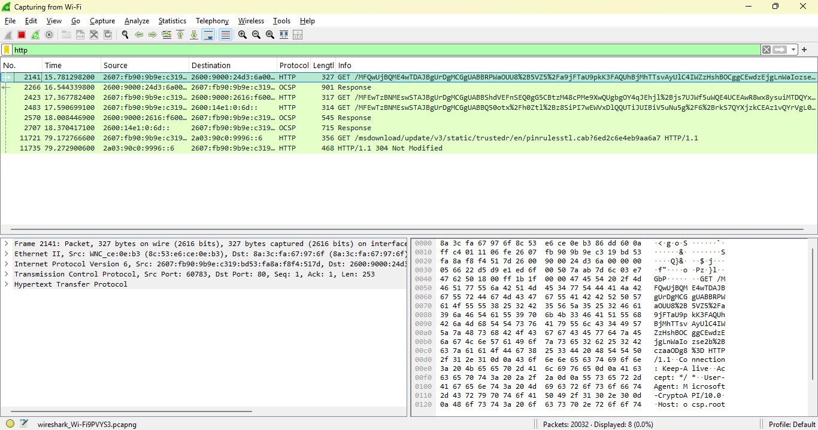
OCSP is part of the TLS handshake
Understanding OCSP helps understand:
- HTTPS
- TLS
- Certificate chains
- Revocation
- Browser security
- MITM detection
✔ OCSP failures can indicate attacks
SOC analysts look for:
- OCSP timeouts
- OCSP failures
- OCSP stapling anomalies
- OCSP traffic to unknown servers
✔ OCSP is used in malware detection
Malware sometimes:
- Avoids OCSP
- Fakes OCSP
- Uses OCSP servers for C2
- Uses OCSP-like traffic to hide exfiltration
Knowing what normal OCSP looks like is essential.

